Order comms request
Pick the Vaccinations Non-Routine Referral
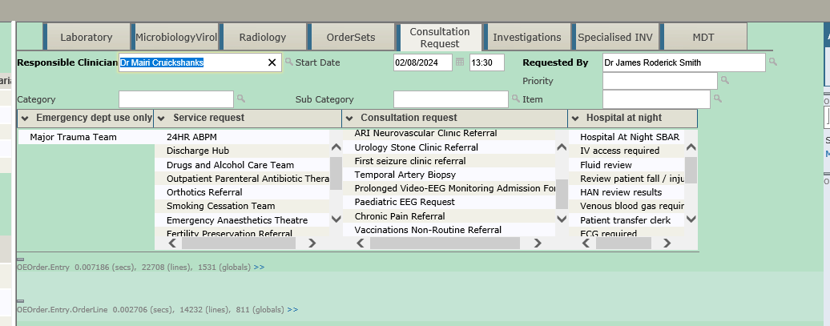

Click on the speech bubble
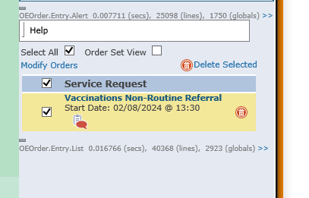

Fill the questionnaire and hit update

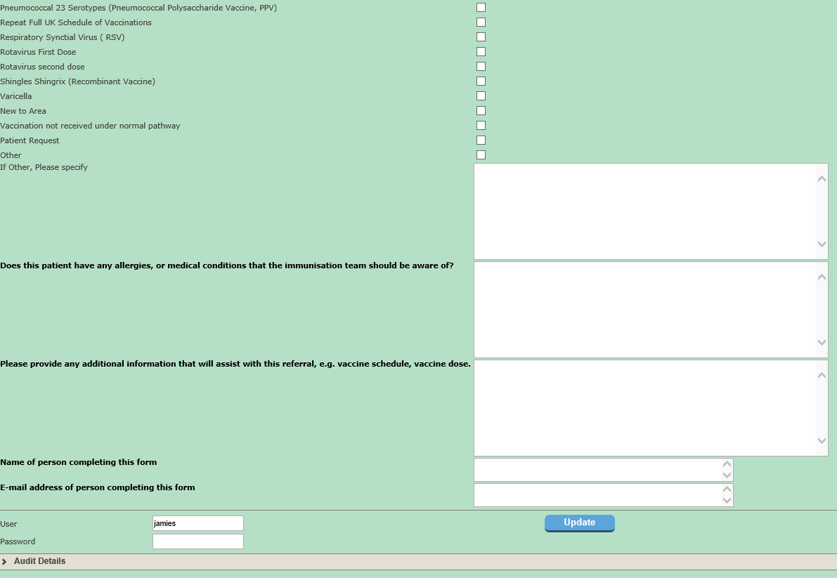

Speech bubble will change to tick so hit update

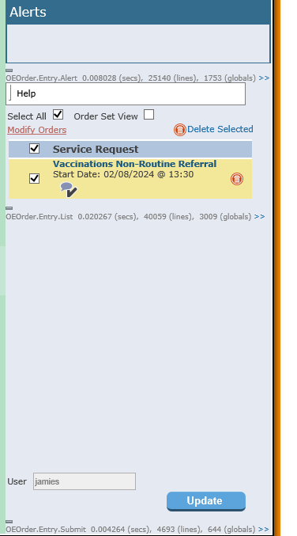
Put in password to complete referral
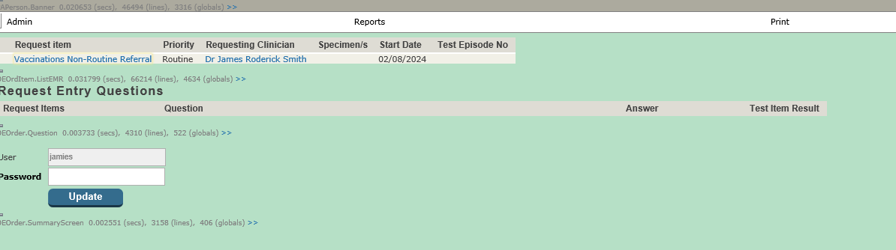

Workbench instructions
Go to service request menu and ensure that Requested, In progress and Completed preferences are set correctly as below
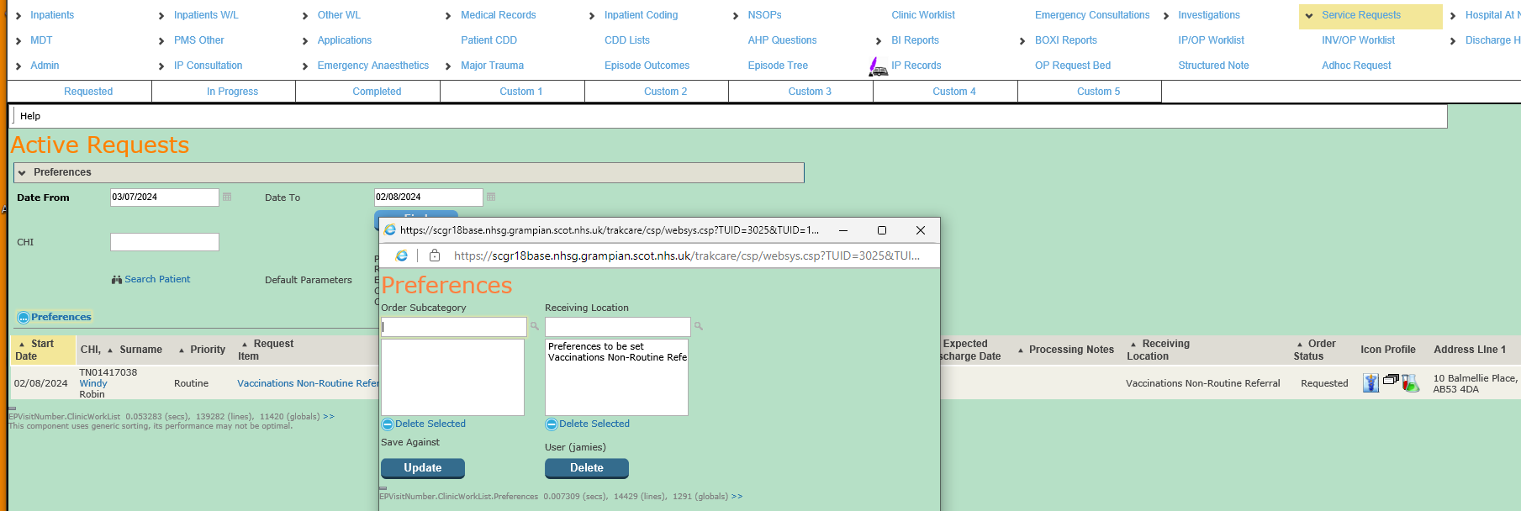

Processing notes and status of request can be accessed and changed by clicking on the request item hyperlink

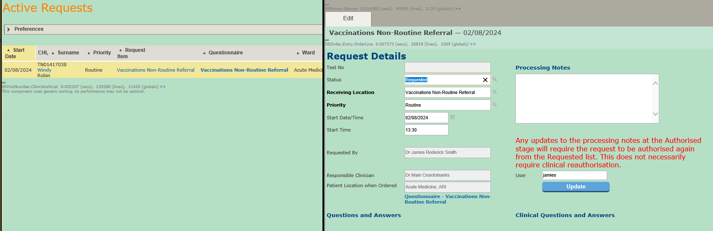

To move the request to in progress use the status App Booked
To move to completed use Executed and to Discontinue use Discontinued.
To Access the questionnaire you can click on the Questionnaire hyperlink above on the workbench on in the patients epr under the service request tab
