College Street Hub
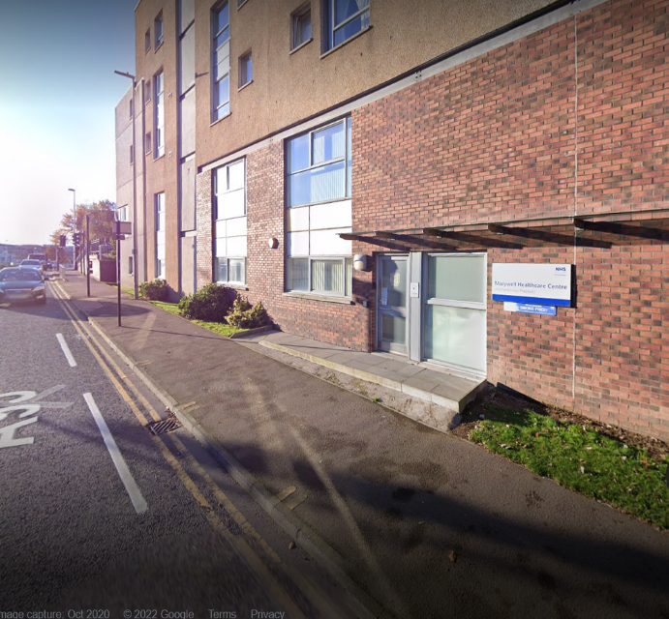
College Street Hub
90 College Street
Aberdeen
AB11 6FD
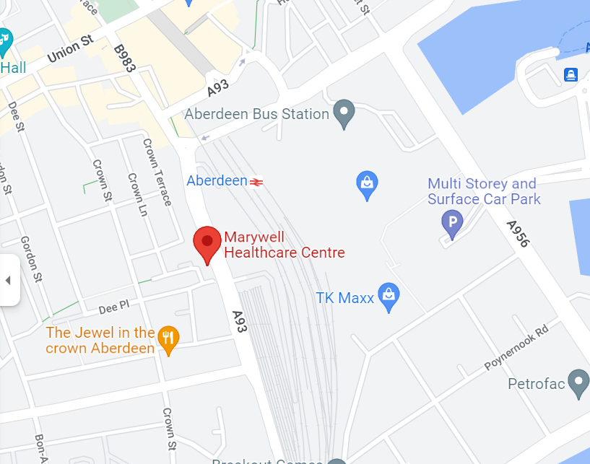
Tel: 01224 551523
Parking - Parking for the Hub is available at College Street car park directly across the road from the clinic. There is also parking in the surrounding streets. Both are pay and display. There is a security buzzer to get into reception.

Healthy Hoose Hub
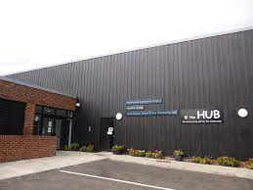
Healthy Hoose
The HUB
Manor Avenue
Aberdeen
AB16 7UR
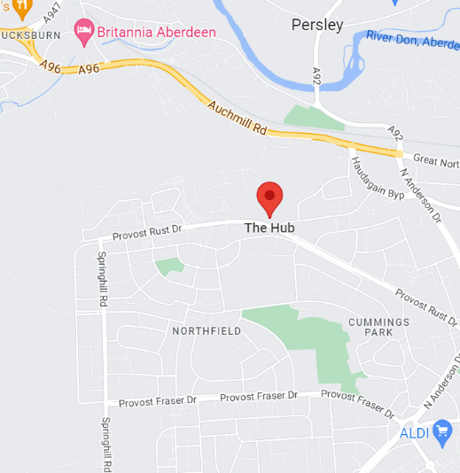
Tel: 01224 551523

Parking - Free parking is available on site at the clinic.

Old Aberdeen Medical Practice
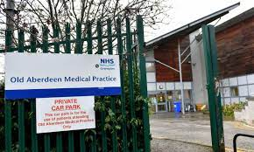
Old Aberdeen MP
12 Sunnybank Road
Aberdeen
AB24 3NG
Tel: 01224 5515523
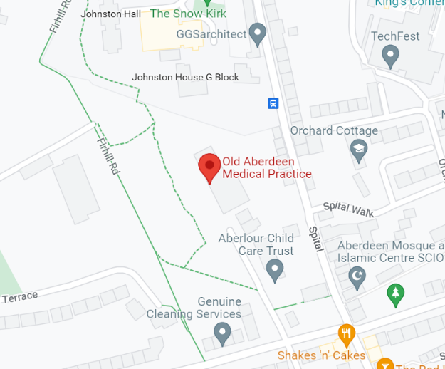

Parking - Free parking is available on site at the clinic.
There is a security buzzer that will be answered by reception.

Bridge of Don Clinic
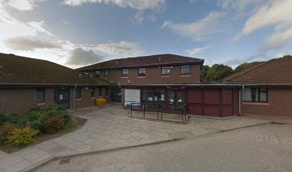
Bridge of Don Clinic
Cairnfold Rd
Bridge of Don
Aberdeen
AB22 8LD
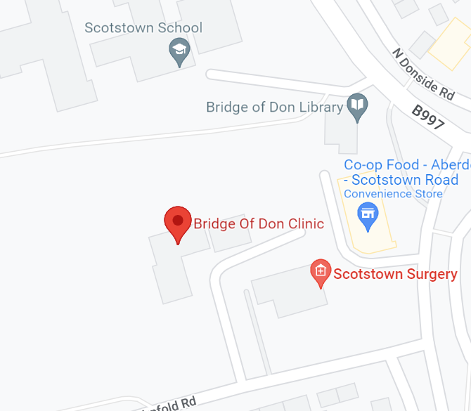
Tel: 01224 551523

Parking - Free parking is available on site at the clinic.

